Bristol Early Childhood Alliance
March 1, 2023 (11:00 – 12:00 p.m.) on ZOOM
In attendance: Maegan Adams, Maureen Eaton, Cecilia Garay, Sarah Guerette, Sandra Godin, Andrew Howe, Kate Kerchaert, Donna Koser, Manny Martinez, Jessica Mitchell, Donna Osuch, Kara Singleton, Jennifer St. John, and Rachael Witkewicz
Introduction: Maureen welcomed all in attendance and asked members to introduce themselves.
Collaborating Grants:
United Way is still waiting to hear about funding for our BECA Coordinator and a stipend for our Parent Ambassador.
CHEFA grant has been submitted on time by United Way. This grant would provide support for a behavioral specialist to continue community work.
Main Street Community Foundation (MSCF) General Grant Cycle opened with applications due March 24. Please contact the Foundation (Kate Kerchaert or Alicia Krar) prior to applying. More information can be found on MSCF website: https://www.mainstreetfoundation.org/
Co-Chair Review: Maureen asked members to consider stepping in to share the Co-Chair responsibilities with her.
Attendance and Summer Slide Discussion: Members present were put into break out groups to discuss the Ice Cream and book event held previously by BECA and ways to encourage reading amongst Bristol students.
Group 1: Jenn, Jessica and Sarah
Discussed how early advertising of the event may be helpful and there may be a benefit of advertising it school wide. We also discussed the possibility of changing the location to the school. We suggested possibly sending the book or welcome bag home prior to the event as an advertisement to the kids/population at higher risk of absence or tardiness.
As far as summer programs we could do a scavenger hunt to promote a special topic. We thought if the topic was reading, BECA could make the clues specific to a theme or summer reading list.
Past virtual book readings, such as the police dept. and others could be something to consider bringing back.
Group 2: Andrew, Cecelia, Sandra
Utilize the new Park equipment for promoting attendance/reading.
Utilizing therapy dogs to draw crowds.
Partner with FRC with four Summer Play n Learn groups.
Group 3: Donna O., Maureen, Rachel
Redistricting will have many schools holding events so principals may not feel need to spend time in one neighborhood with the ice cream truck, but the district is not holding activities related to the new Academy. Maybe time to let the original format go and instead think about bringing the truck to the Pre-K Academy only.

Don’t want to step on the library’s toes for a reading challenge, but perhaps encourage activities throughout the summer to turn off screens, implementing a BINGO card for outdoor events/programs with a prize of an ice cream truck or other incentive at the Pre-K Academy.
Group 4: Manny, Kate, Kara
Solidify a presence at events already happening. Perhaps switching to popsicles rather than ice cream.
UWWCC could create a challenge with our neighboring communities with a point system. Businesses might be interested in providing incentives (such as a Bristol Blues game, ice cream cone, etc.).

After a brief discussion, it was decided that the great ideas shared would be brought to the Outreach Committee and possibly divided amongst our committees. Kara volunteered to put electronic materials together once we come up with a plan.
BECA Committees:
Health – Next Meeting: March 14, 2023 at 3:00 p.m.
Infant & Toddler – Next Meeting: February 21, 2023 at 1:30 p.m. – Note: this time may change.
Transition to K - Next Meeting: March 20, 2023 at 3:45 p.m. –
Outreach – Upcoming events:
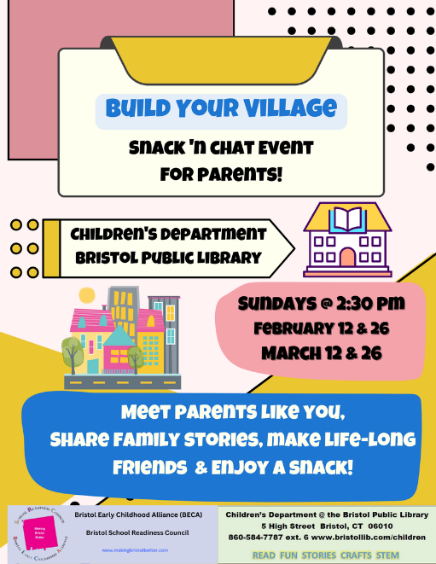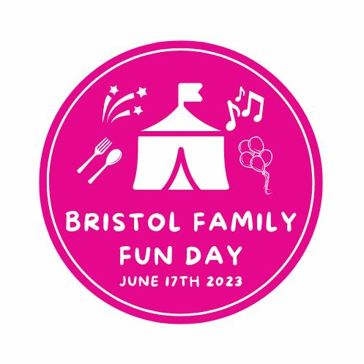

Community Sharing:
UWWCC – VITA (volunteer income tax assistance) program is up and running and accepting clients until April 14th. If you know anyone who needs free tax preparation and meets the requirements, please have them sign up. Donna K. to send a flyer.
MSCF – Scholarship applications will be due March 10th. Share with any high school senior and/or current college students. Check out the website for more information: https://www.mainstreetfoundation.org/scholarships
FRC – 4 parent ed classes focused on Development and Discipline have been scheduled. Classes will be held in English & Spanish. Parents who attend will receive a parenting book and children will receive a children’s book. Dates for the summer play and learn groups should be solidified soon.
Parent Ambassador – Build Your Village series is continuing. The next session will focus on simple organizing strategies for families with a professional organizer.
SR – Legislative session update – if anyone is willing to submit testimony and/or tell your legislature about what is going on in the programs/communities, Donna O. is available to help.

Next meeting: April 5, 2023 (on ZOOM)

