Bristol Early Childhood Alliance
Meeting on ZOOM
August 3, 2022 (11:00 – 12:00 p.m.)
In attendance: Meagan Adams, James Costa, Emily Diaz (UW Intern), Maureen Eaton, Richard Hart, Mary Beth Hicking, Andrew Howe, Donna Koser, Tracy Krasinski, Donna Osuch, Jenn St. John and Mindy Wallen
Upcoming Events:
- I/T Breastfeeding Celebration in the Park
August 6 10 AM – 1 PM – Please reach out to Lauren Kittle if you would like to have a table.
- Appetite for Reading Book Dist. At Rockwell Park Music Festival
August 9 at 6:00 PM – Maureen will be present.
- Walk & Talk with a Parent Ambassador
August 11 @6:00 PM – Please share flier with parents
- Rockwell Park Summer Festival, August 20, 10 AM – 6 PM – If you can give an hour or two, please reach out to Donna Koser
- Mayor's Back to School Pencil Hunt (Participation Pending) – James Costa and Andrew Howe will confirm if BECA can participate as we did prior to COVID.
August 25

In our last Outreach meeting a “Mini Carnival” similar to the event in the movie “Daddy’s Daycare” was discussed. This event will allow BECA to do outreach, share resources with families. The event would target families with children Birth to age 8. Since the Outreach Committee only meets quarterly, a planning subcommittee is needed. The following are interested: Maegan Adams, Donna Koser, Donna Osuch, Jenn St. John, Maureen Eaton, Chief Hart, Mary Beth Hicking, James Costa, Andrew Howe.

Collaborating Grants:
United Way was not awarded continuation funding for Sparkler. Parent Child Program and the Bristol FRC will continue to monitor incoming Sparkler families.
CT Council for Philanthropy has awarded funding. A portion of this funding is for Parent Ambassadors. One has stepped down and a replacement is needed. If you know of a parent who is interested, please reach out to Donna K.
Parent Trust Fund – Bristol FRC will apply for UCONN PEP again next year.
MSCF has opened the grant cycle for “Women and Girls Fund” and “Men and Boys Fund” – both due Sept. 19th. If you are interested in applying, please reach out to Kate Kercheart first.
MSCF also “Immediate Response Grants”. One time grants up to $500.00 for unexpected financial needs/assistance. Funding must be requested from a Social Service provider and not the individual.
Tracy will share information on “Pathways to Prevention” grant that is due Sept. 16, 2022 for programs that may be interested in applying.
Donna O. reminded all in attendance that this line item was added to make sure information gets out to everyone and to ensure that collaboration on grants, when possible, is being considered.
Survey Discussion:
The Leadership Team asked for feedback for planning the year of meetings for BECA. Survey results and discussion follow:
Question 1 (a): If you answered no to the above question, were not at that meeting or want to add something, please provide your "why am I here" answer (and, if applicable) your reason for adding or changing it.
Why am I here?
·To share public health information, learning & sharing
·Interest in women and health
·Support and enhance nutrition in the community
·Provide infant health perspective
·Learning about resources in the community
·Learn about resources to inform Spanish speaking families in the community
·Childcare work is valuable, and I want to improve the education and well-being of children
·I am not a CC provider and I want to keep informed of issues affecting childcare and help find solutions and funding for them – provide an outside perspective
·Mission of FRC is Family/School/Community partnerships. BECA is an important community partnership, helps me id resources and develop programming
·We need to remember why we do what we do – I am passionate about little ones and want to advocate for them

Question 1 (a): If you answered no to the above question, were not at that meeting or want to add something, please provide your "why am I here" answer (and, if applicable) your reason for adding or changing it.
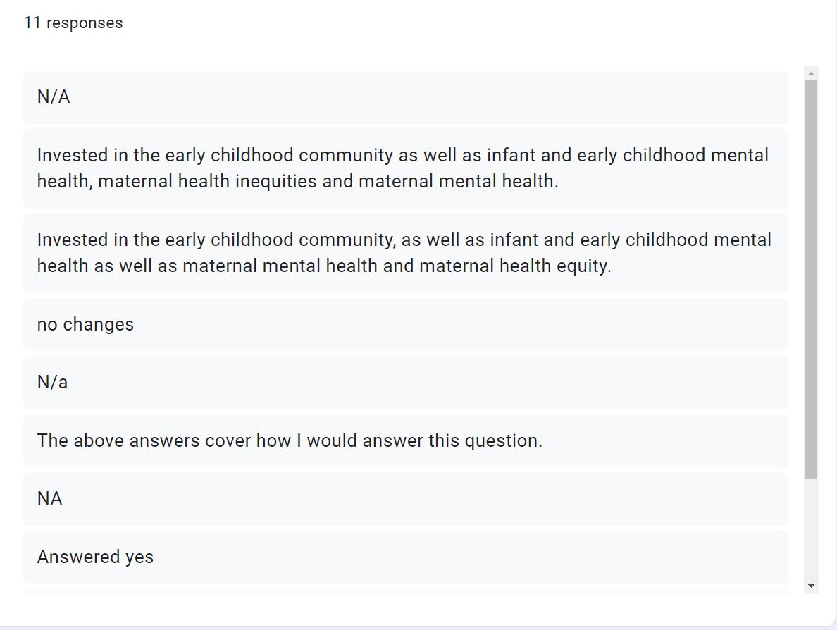
Question 2: Do you have anything to add to the following list (created in our December 2021 meeting?

Topics to learn about/Speakers
·Kids vaccine – learn more for the community
·Effects of COVID and how each age group has been impacted.
·Solutions based discussion on Mental health needs of kids
·Autism in the schools – resources, including successful use of robots with autistic and developmentally delayed children (Movia Robotics)
·Website/Social media experts help us with outreach to get more people involved in BECA and spread the word. We are not experts in this area.
·What do school administrators want to see in the kids entering school? What are their recommendations?
·Kids vaccines
·Effects of COVID 19 and the age groups it has affected.
Other
·We need a legislative body to advocate for us (Early CC)
·We need (additional) BOE representation on BECA
Groups were asked to discuss the survey results in small groups:
Group 1: Emily, James and Jenn
- Sharing Resources in other languages besides English and Spanish. There are many other languages in Bristol.
- Provide a picture for each member, listing their role/agency on the Alliance and contact info.
- Quest Speaker – perhaps the Mayor to present to give a different perspective or a Kindergarten teacher to let us know how the incoming K students are in comparison to those who were born pre COVID.
Group 2: Richard Hart, Mary Beth, Maureen and Mindy
- Information on how to get information/resources to families with children with special needs. Many times it is a lengthy process and early access to services can make a difference.
- Mental Health – top of mind – how to get families the resources need. Donna asked everyone present to please share any resource for our website that might be useful to families.
Group 3: Andrew, Donna O. Maegan and Tracy
- Ask other local collaboratives how they are structuring their meetings.
- School Readiness may meet quarterly “in person” – would BECA be following?
- Continue with Guest Speakers – plan out the year.
  - Pediatrician to speak about vaccines or social/emotional wellbeing of children
- Each of the different committees have time to present throughout the year or schedule the committee meeting during the BECA meeting with break out groups.
  - Make sure it is not a repetitive meeting.

Committee Updates:
Infant and Toddler Committee will hold its annual event this coming Saturday. The next meeting is scheduled for Aug. 16th at 1:30 PM
Health Committee and Transition to K will resume meetings in the fall.
Parent Ambassador Update/Community Sharing: Donna K asked everyone to send information to share on Making Bristol Better or sent via email to members.
Jen shared that the first Walk and Talk was not very well attended and hopes that the next event planned for during the week will be better attended.
Chief Hart announced that “Okee” the firehouse dog, will arrive to the fire station on Friday. A “Welcome Okee” event is in the works. Okee will begin community outreach/education in October.

Next meeting: September 7, 2022

