Bristol Early Childhood Alliance
Bristol Board of Education
September 6, 2022 (11:00 – 12:00 p.m.)
In attendance: Meagan Adams, Kristina Duarte, Maureen Eaton, Christine Gavage, Cecelia Garay, Sandra Godin, Linda Ivey, Lauren Kittle, Donna Koser, Alyssa Marin, Manny Martinez, Andrea Mead, Donna Osuch, Kristen Peck, Jenn St. John, Kara Singleton, Kristina Tanguay, Mindy Wallen and Rachael Witkewicz
Introduction: Maureen and Lauren welcomed all in attendance and asked members to introduce themselves. It was great seeing new faces.
Collaborating Grants: Sparkler is continuing with programs without funding. Family Fun Day is looking for supporting grants that focus on health, literacy, school readiness and/or family engagement.
Presentation: Bristol Burlington Health Department (BBHD) presented on “Understanding the Bristol Referral System and Medical, Mental Health and/or Social Issues”. BBHD cannot help in finding a solution to a problem they do not know about and the BBHD Family Outreach Team encourages agencies to let them know “What is working and what is not working”.
Members present were also reminded that the “Case Consultation Meeting”, currently being held on Zoom, is a great resource for providers.
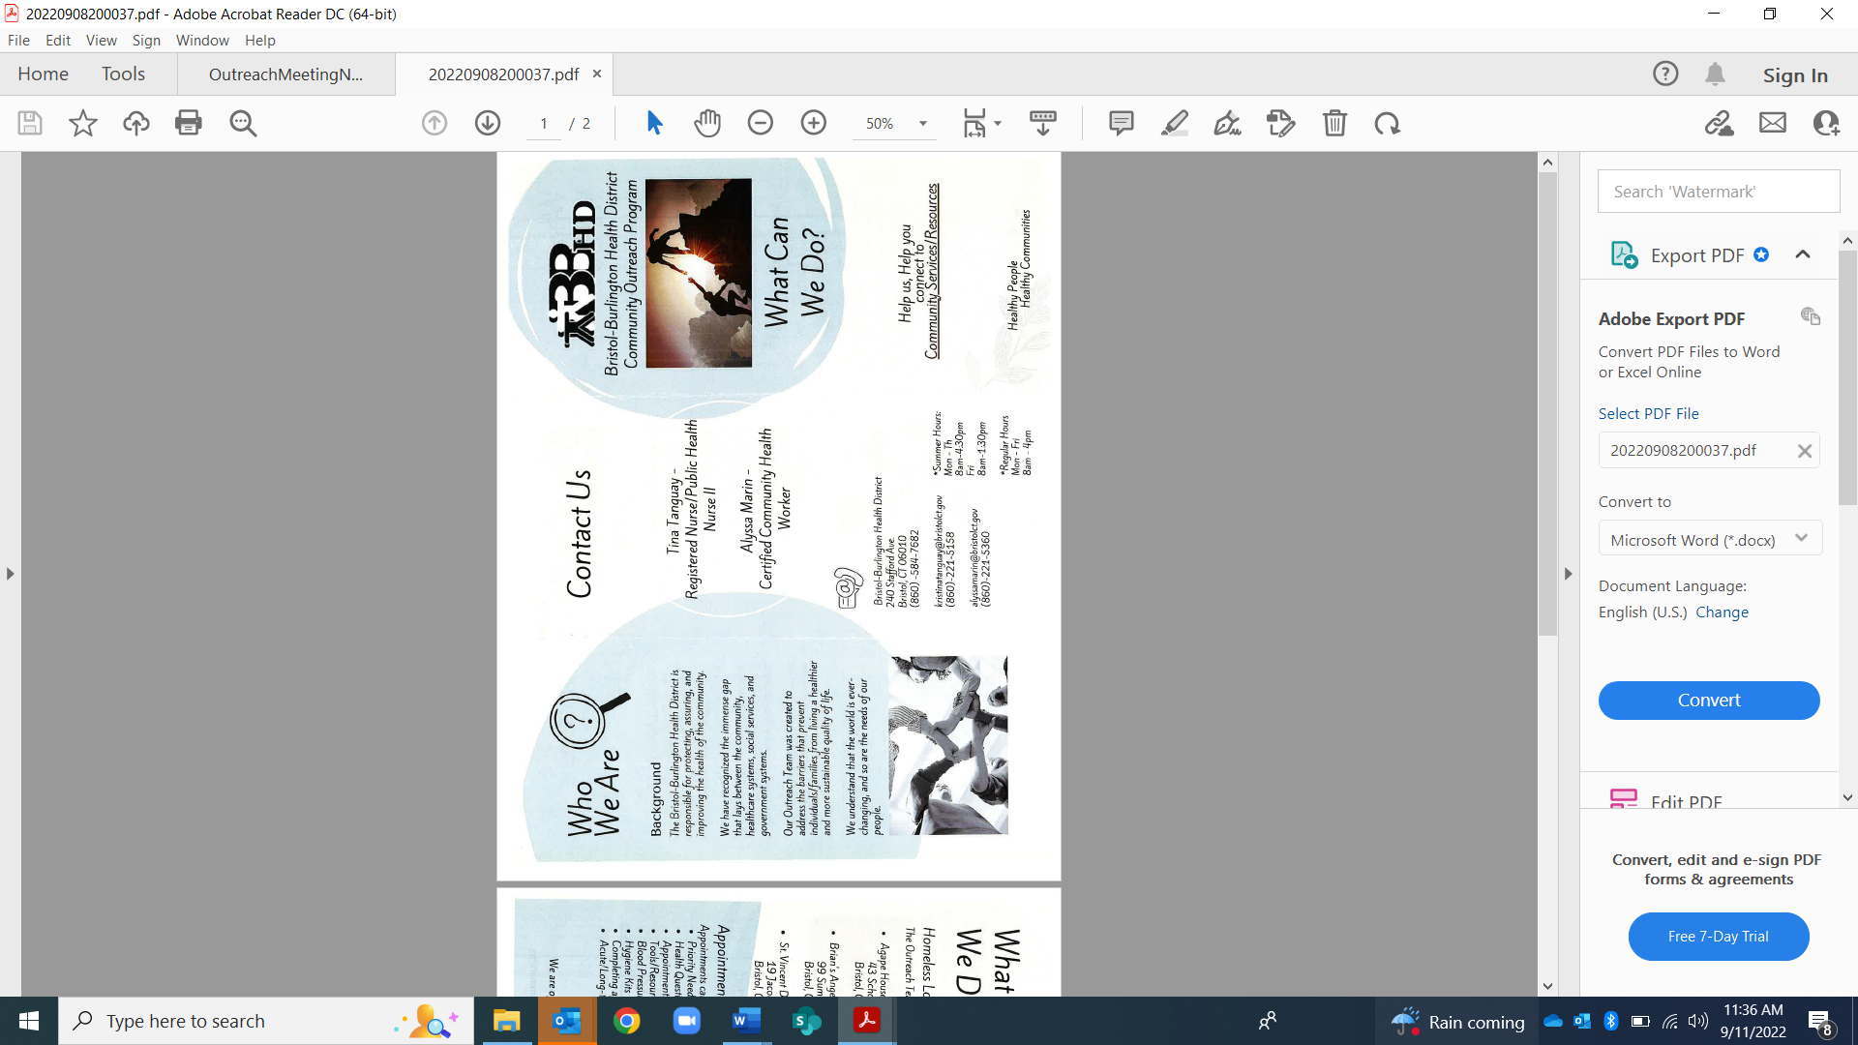

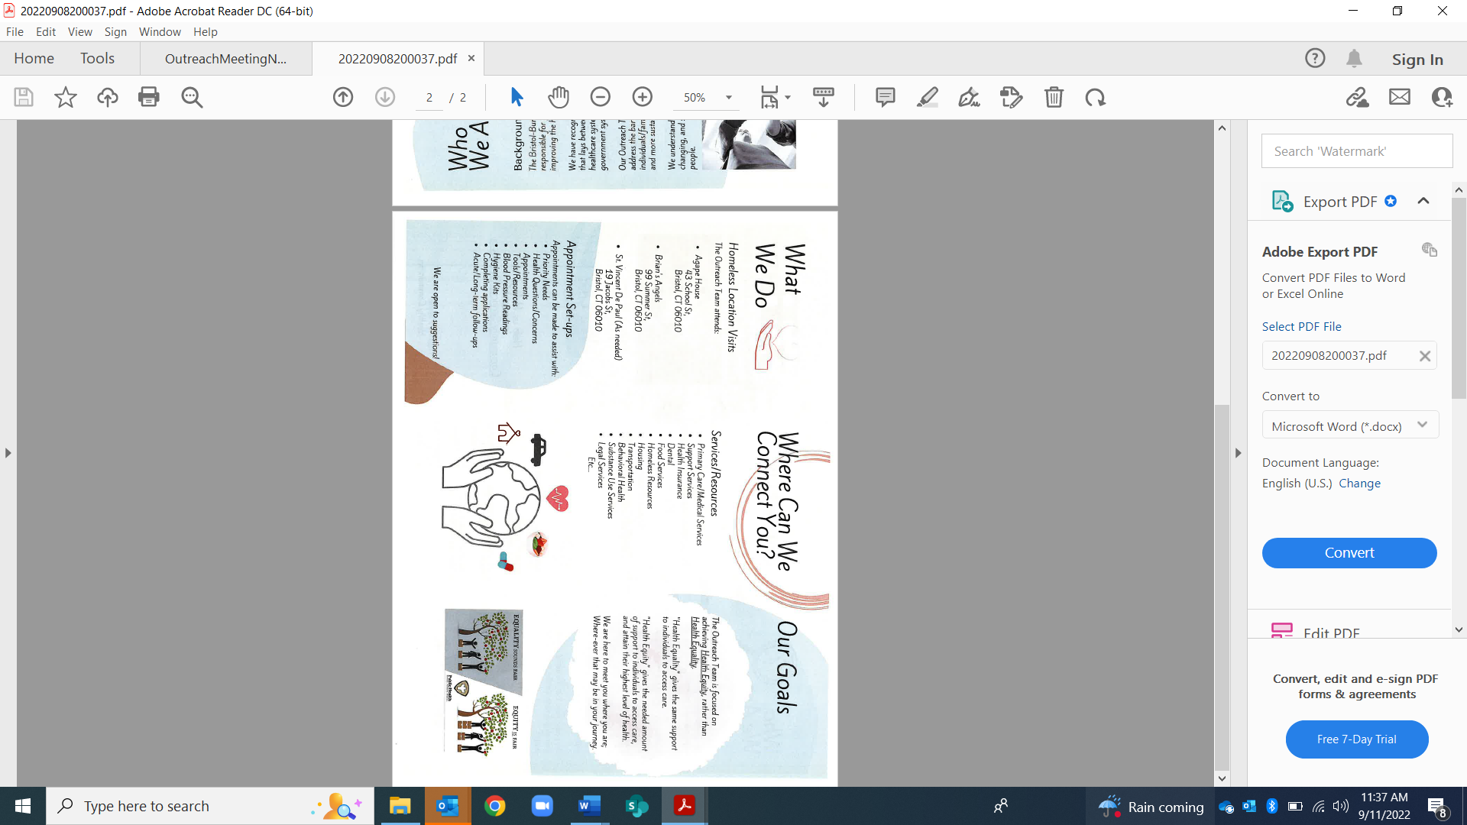

Committee Updates:
- Health – The first meeting of the year was held on 9/6. Meetings will be held the second Tuesday of each month at 3:00 p.m. The October meeting will focus on setting goals for this committee. One statistic that the group might focus on was information shared about Bristol being #1 in Connecticut in neonatal abstinence syndrome (NAS).
- Infant and Toddler – The World Breastfeeding Celebration was held at the Bristol Public Library on August 16th. The next meeting will be held on September 20th and will focus on goal setting for the year – supports available, information/data to gather and resources needed for the community.
- Transition to Kindergarten – The committee has not met since May. The First Day of School Firetruck Ride was successful with two lucky Kindergarten students who arrived at school with a smile. The next meeting will be held on Zoom, September 19th at 3:45 p.m.
- Outreach Committee – The last meeting was held in July where a subcommittee for “Family Fun Day” was initiated. The next Outreach meeting will be held on Zoom on January 19, 2023, at 10:00
- Parent Ambassador Update: The first meet and greet and several “Walk and Talk” in the Park events were held. Reading Buddies and Appetite for Reading books were distributed at the Rockwell Park Music Festival, Farmers Market and Rockwell Park Summer Festival. There were many opportunities to chat with parents who were not aware of all that Bristol has to offer their families.
- Family Fun Day: The committee will finalize a date at the next meeting and is looking for a time that will not conflict with sports and the end of year school events. The focus of the event will be birth to age 9 and will promote health and wellness, literacy, and school readiness. The next meeting is scheduled for Monday, Sept. 12th at 10:00 a.m.

Community Sharing:

Parent & Child Program – Developmental Play Groups are full for this session and recruiting for the next session. A diaper and wipe drive will be held on Oct. 1st.
MSCF – Women and Girls Fund is due 9/9 and Men and Boys Fund is due 9/15
Hartford Healthcare – Grants are available for mammograms.
FRC – Play and Learn groups were finalized for the year, all updates have been announced on the Facebook page. FRC will begin district wide ASQS. PEP Partners now has a 5th team.
BBHD – is holding a baby shower on Oct. 1st.

Next meeting: October 5, 2022 (IN-PERSON)

